**Module-6: Ansible Assignment - 2**

You have been asked to:

● Create a script which can add text “This text has been added by custom script” to

/tmp.1.txt

● Run this script using Ansible on all the hosts

On master

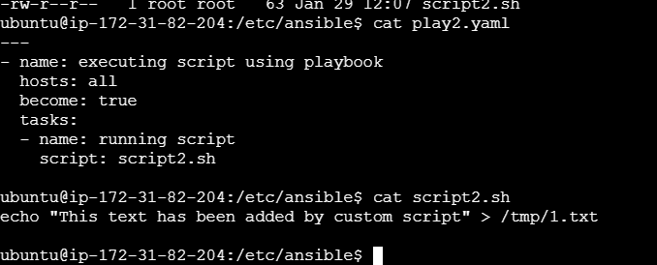

Checked the syntax

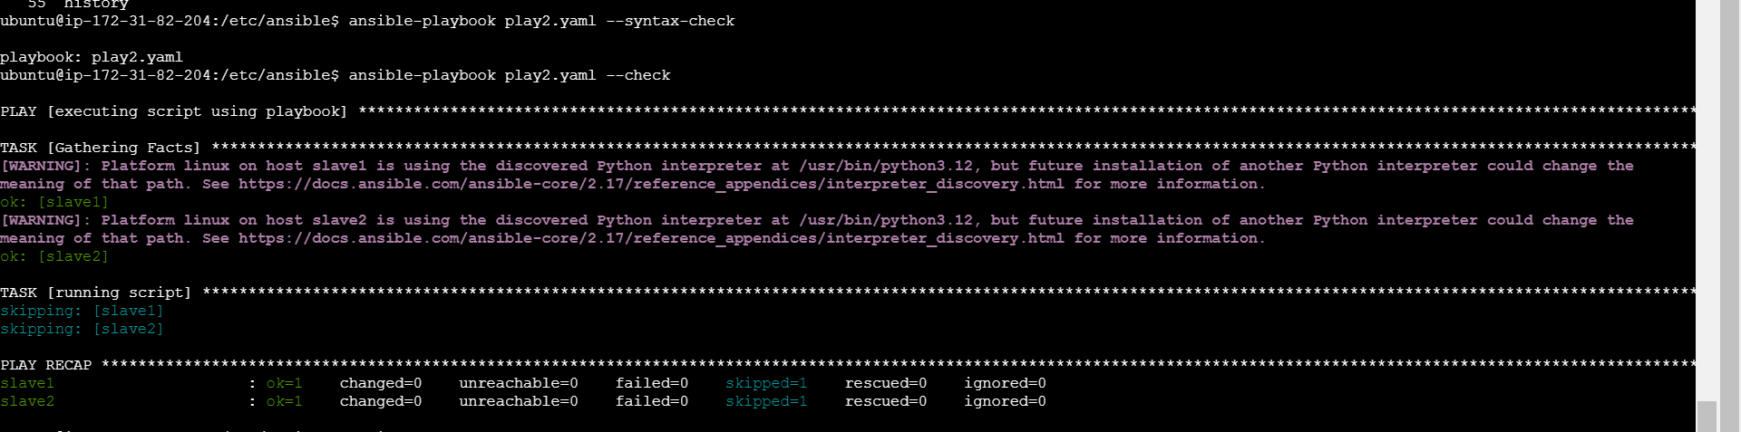

Execute the playbook

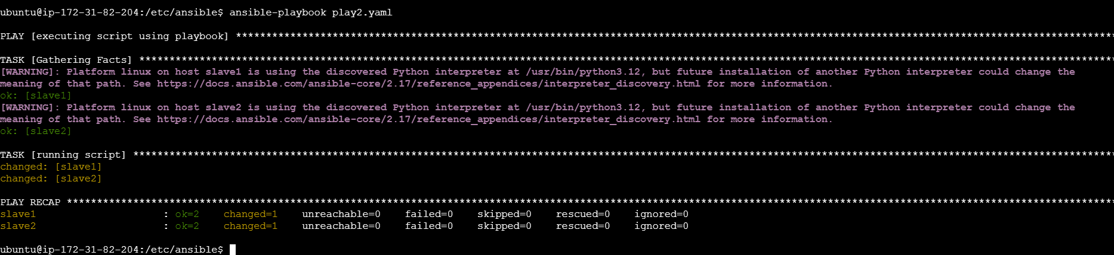

Verify on slave1 1.txt file created.

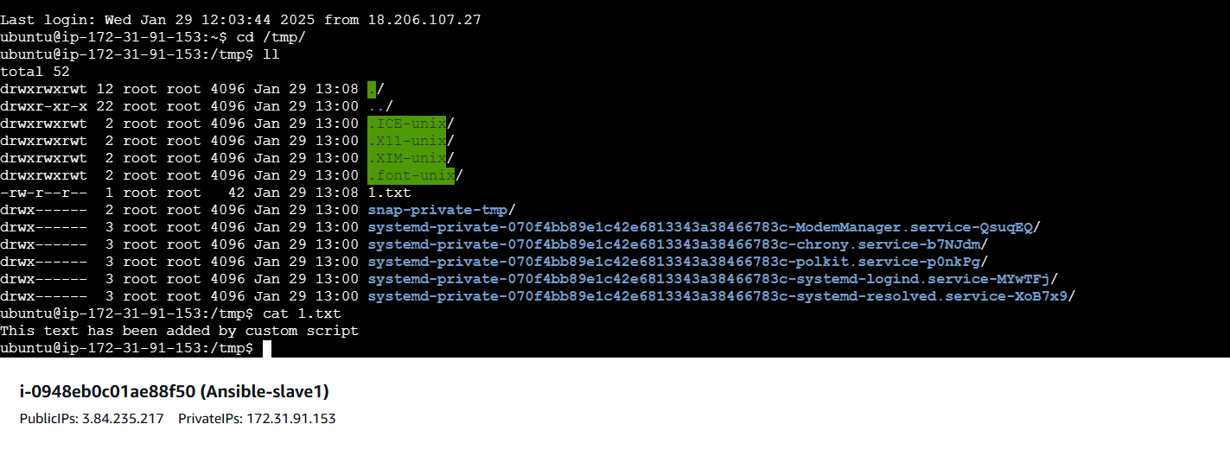

Verified on slave2 1.txt file created.

